DELAWARE COUNTY PARALEGAL ASSOCIATION

2014 Back Pack Drive

For benefit of the children served by
City Team Ministries

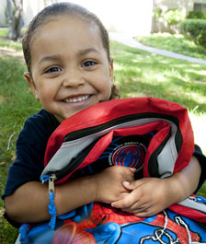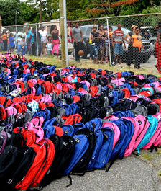

The School Supply Wish List Includes:

Backpacks
3-Ring Binders
Lined Paper
Pencil Holders
#2 pencils
Pencil Sharpeners
Erasers
Glue/Glue Sticks
Colored Markers
Highlighters
Plastic Rulers
Blunt Scissors
Index Dividers

Cash donations are also welcome!

Feel free to take a copy of the school supply list with you and return with some items!

Thank you…………………..

